ENG2P9 Exam Review
Terms to know
Review the following terms and make sure you:
- Can spell them
- Know the definitions
- Know how to use them in a sentence
Literary devices (Practice – Mix and Match)
- Allusion ___Her lovely long locks and lashes were every girls’
envy.

- Personification ___Crunch went my finger as I slammed it in the door.

- Metaphor ___The gentle rain fell softly on the new grass outside as
the smell of bacon reached my nose.
- Simile ___The waves licked at the rocks along the shore.

- Hyperbole ___ I soon found myself sitting in the pit of despair.

- Alliteration ___His smile was like the sun lighting up my day.

- Onomatopoeia ___My alarm rang for the millionth time this morning.

- Imagery ___My mother is a regular Martha Stewart in the
kitchen.
Short story terminology:
Conflict + types _______________________________________________

Antagonist ___________________________________________________

Protagonist___________________________________________________

Setting______________________________________________________

Theme______________________________________________________

Major vs Minor Characters ______________________________________

News Article terminology
Identify and label the Headline, Lead, 5 Ws and H, Caption in the article below.

Man, 80, charged for driving car almost completely covered with snow

The driver from Brussels, Ont. was pulled over when police saw his car was covered from roof to bumper with what looked like close to 30 cm of snow.

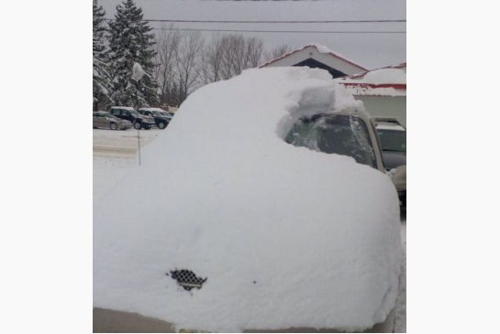
COURTESY OF THE OPP / COURTESY OF THE OPP
This car was pulled over by the OPP near Brussels, Ontario.
By: Peter Goffin Staff Reporter, Published on Wed Jan 20 2016
It might be hard to tell, but yes, there’s a car under all that snow.
On Tuesday afternoon, the OPP’s West Region twitter account posted a photo of a car covered from roof to bumper with what looked like close to 30 cm of snow.
Only a small hole had been made in the blanket of white, over the driver’s side windshield and door.
The OPP said the car was pulled over earlier in the day near Brussels, Ontario.
The driver, an 80-year-old local man, was charged with driving with no clear view and faces a $110 fine.
Police say he was just going for a short drive in town.

Short Story.
Read the short story “Charles” by Shirley Jackson and then label the plot diagram. With introduction, rising actions, climax , falling actions, conclusion and the matching events from the story in the space provided.

