Calculated Choices
Only1rob
September 27, 2010
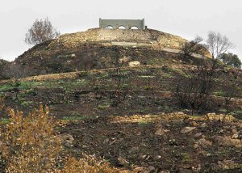
Brushing his hand across the tree trunk, Eric took short, low breaths and marveled at the air. How clear it had become in just a few short months, crisp and clean as billions of motors, power plants and more had shut down. Even away from the city he had never smelled anything like it, it’s pure arom,..
“Break his knee caps”
Eric looked up, startled, as the two men stood over him.
“Look, guys, I know I’m not the fastest one here but, but why?” he asked not quite believing his situation.
The first man looked at him, weighing him in his eyes, a simple calculation that life had become “There’s a group of them coming toward us from the south, and we need to slow them down until we can get to higher ground.” Eric looked at him with wild eyes “It’s nothing personal.”
Backing away Eric held up his bound hands, palms open. “Hey, hey, hey, there’s got to be another way, maybe if we just stay quiet we can avoid th” his words were cut short by a simple, sharp, “No” from the man. “So that’s it then? What? I’m just a decoy? You caught me, bound me and dragged me all this way, as a decoy?”
“Yes”
Eric didn’t see the man behind him, but he felt the searing pain as the club smashed into the side of his leg. Falling to the floor screaming, he tried to raise his arms to stop a second blow, missed the club and felt his other kneecap explode as the weapon was brought down directly on it.
Turning from the screaming, broken figure the man motioned to the others “Let’s go! We need to get up this hill before they get done with him.” With that the group moved away, climbing the steep hillside as the first of their pursuers emerged from the tree line and made its way to Eric’s sobbing figure.
The man, cold from a hundred similar decisions turned at the top of the hill and looked back. After a few moments, he nodded, sure that the pursuers, one more in number, were unable to climb the steep rocky hillside. Making his way after his group he looked over the most recent captives and mentally marked the next one.

